Systems Requirements for the Events Application
Thuan Nguyen
Nhu Tran
Tuyet Nguyen
Professor Ronald D. Davis
March 8th, 2025

Part A: System Requirements for the Mobile Application Subsystem
What It Needs to Do (Functional Stuff):
- App Basics: There’s got to be a mobile app that people can download and use on their smartphones or tablets—pretty straightforward.
- Map Features: Users should be able to pull up maps in the app to get details like addresses or location info whenever they need it.
- Reminders: The app should let folks set up reminders right on their device, so they don’t forget important stuff.
- iOS Support: It’s got to work smoothly on iPhones or iPads running iOS 15.0 or anything newer—no leaving older devices in the dust.
- Event Browsing: Users should be able to scroll through a list of upcoming events tied to the University of North Alabama campus, or at least nearby.
- University Calendar Sync: The app needs to grab details from the University’s calendar—like event names, dates, and who’s involved—so everything stays up to date.
- Custom Event Scheduling: Some users should have the ability to add their own events through the app, especially for stuff that doesn’t make it onto the official University calendar.
- Restricted Access: Only a handful of trusted people or groups should get the green light to schedule events directly in the app—keeps things organized and secure.
Operational Stuff:
- Budget Cap: The whole subsystem can’t cost more than $5,000 upfront—got to keep it affordable out of the gate.
- Running Costs: Once it’s up and running, it shouldn’t eat up more than $1,000 a year to keep going—no budget busters here.
  - .
Maintenance Needs:
  - Uptime Goal: The app should be online and working 99% of the time each year. That’s just 8.76 hours of downtime tops—like, barely a day off.
  - Auto-Updates: The system’s parts need to check for software updates on their own and install them when they’re ready—no babysitting required.
  - Disposal Cost: When it’s time to ditch the subsystem, it shouldn’t cost more than $500 to get rid of—cheap and easy cleanup.
Part B: Digging Into Use Cases and Actors
1. What People Want to Do (Use Cases):
- “Create New Event”: As a club leader at UNA, I’d love to pop our upcoming events into the app so more folks hear about our club and what we’re up to.
- “System Makes a Post”: As a UNA faculty member, I want the university calendar events to automatically show up in the app. It’d save time—no one has to manually post them—and get more eyes on what’s happening.
- “User Map Info”: As a UNA student, I want the app to guide me straight to event locations using the iOS maps app. No messing with typing addresses or stressing over typos—just point me there.
- “User Reminder Info”: As someone using the app, I’d like it to let me set reminders right on my phone. It’d make keeping track of events quick and painless.
- “System Saves Event Data”: As an app user, I want it to hang onto details from past events—like dates and times—so we can plan future stuff around them or avoid clashing with annual traditions.
2. Who’s Involved (Actors):
- UNA Students: The ones checking out events and using the app to get around.
- UNA Faculty: People who want university events shared without extra work.
- UNA Club Leaders: Folks posting their own club happenings.
- UNA Online Calendar: The source spitting out official event details.
- Database Memory: Whether it’s UNA’s or another one, it’s where all the event info lives.
- UNA Employees: The crew keeping the system humming behind the scenes.
- iOS Maps App: The tool helping students find their way.
- iOS Reminders App: The handy sidekick for setting event alerts.
3. Use Case Diagram
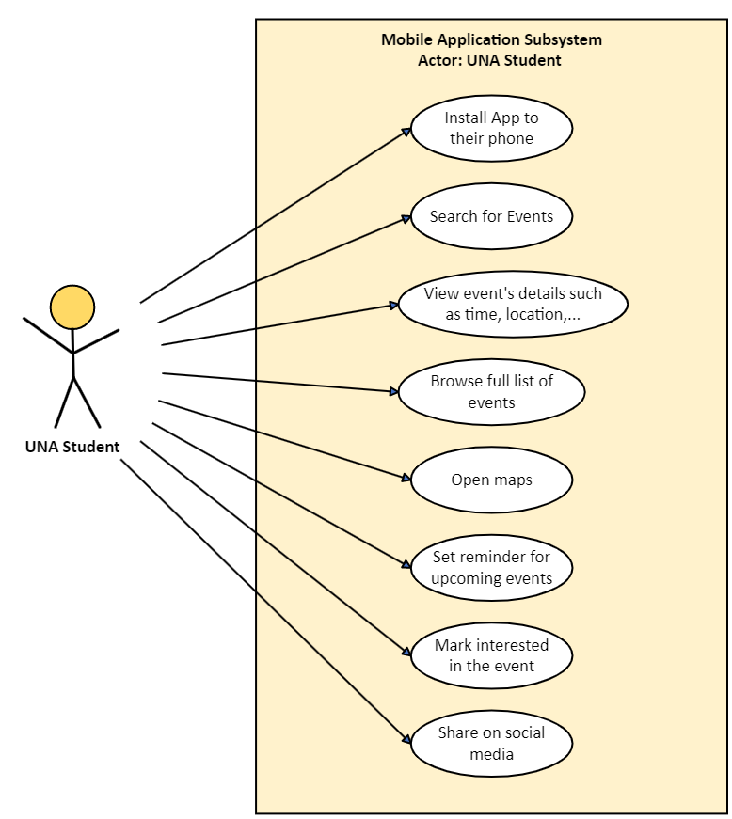
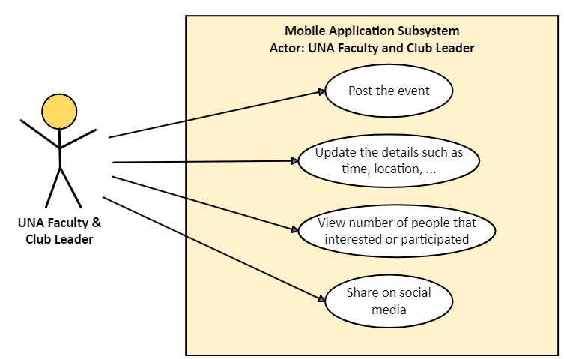

4. Domain Model Class Diagram
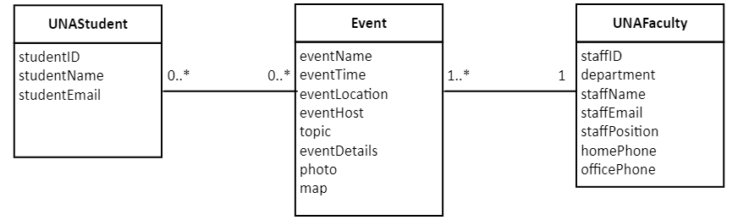 Note: This diagram aligns with the semantic net discussed earlier:
- A student can look up or show interest in zero or more events.
- An event can be seen by zero or more students or users.
- Each event is created by exactly one staff member or club leader.
- A staff member can post one or more events.

5. State Machine Diagram for the Event Class
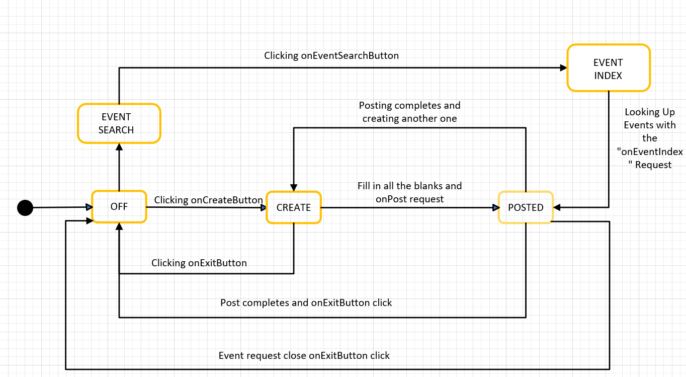

6. Use Case Description
Use case name: | An event is imported from the UNA calendar.
Scenario: | Scheduling an event in the events app.
Triggering event: | It all kicks off when someone schedules a new event on the UNA calendar.
Brief description: | A user on UNA.edu makes a post to the UNA calendar. The system then detects the new post and ports the event over into the events app with a new post that mimics what is on the calendar.
Key Players (Actors): | - UNA database  - UNA calendar  - UNA faculty
Related use cases: | The event may be stored into the database and would invoke the use case that saves things into the database relating to past events.
People Involved (Stakeholders): | - UNA faculty  - UNA students
What Needs to Be in Place First (Preconditions): | - The system that pulls info from the calendar has to be up and running.  - There needs to be an event already scheduled on the calendar for anything to move over to the events app.
What Happens After (Postconditions): | - The event gets stored safely in the UNA database.  - A matching post pops up in the events app, reflecting the same info as the UNA calendar.  - The app keeps track of details like date, time, and location, so the reminders app and maps app can step in to help users out.
Flow of activities: |  | Actors | System
 |  | - Someone Decide to Add an Event  - The Post Goes Live on The Calendar  - System picks up new post and mimics the post to fit into the events application. | 1.1. Gathering Event Details Going into the UNA Calendar.  2.1. Using that Information for the Calendar Post  3.1. Collecting Key Information about Events Like Date and Time.  3.2 Turning That Information into An App Post.  3.3. Posting and Saving Everything in UNA Event App.
Exception case: |  | - Detection Glitch: Sometimes the system hits a snag and can’t pick up a new post added to the calendar—maybe a technical hiccup gets in the way.  - Duplicate Post: If there’s already a post out there that’s identical word for word, the system might stumble because it thinks it’s seen this one before

7. Activity Diagram for Create New Event Use Case:
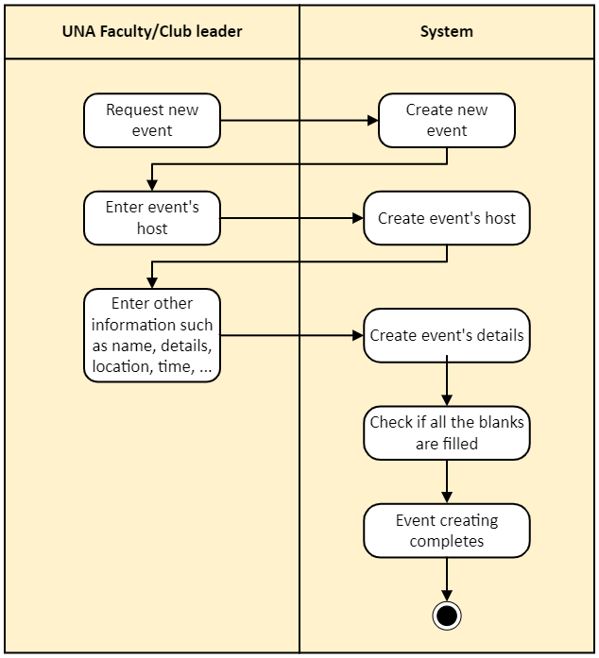

8. System Sequence Diagram for Create New Event Use Case:
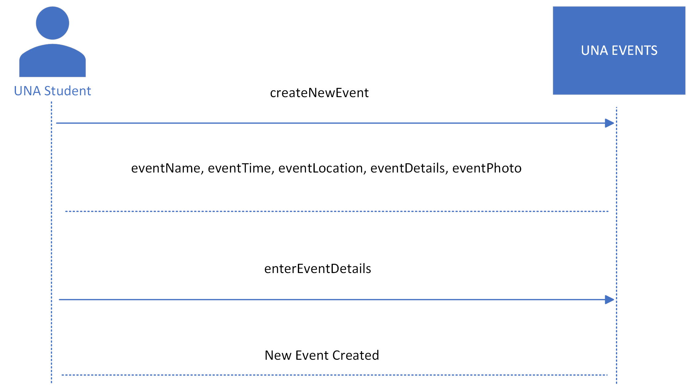
9. CRUD Matrix

Use Case/Domain Class | UNA Student | Faculty | Club Leaders
Create New Event | C | C | C
System Makes a Post | U | U | R
User Map Information | R | CR | CR
User Reminders | CR | R | CR
System Saves Event Data | UD [archive] | UD [archive] | UD [archive]

